
ROLL NO: 26K-3142
CLASS: BSE-1D
NAME: ABDUL RAFAY NAWAZ
PF_BSE_Lab (1D)

Date: 9/17/2026
Mr. Shayan Ali
Post Lab 4 Tasks
Task 1

A university offers a scholarship to students who have either obtained 80% or above marks OR have a family income below Rs. 50,000. Write a C program that takes marks and family income as input using scanf(). Use relational operators, the OR (||) operator, and if-else to determine whether the student qualifies for the scholarship.

CODE
#include <stdio.h>
#include <conio.h>
int main()
{
float a, b;
printf("Enter student marks in percentage %%: ");
scanf("%f", &a);
printf("Enter family income in Rs. ");
scanf("%f", &b);
if (a >= 80 || b < 50000)
{
printf("Congratulations! The student qualifies for the scholarship.\n");
}
else
printf("The student does not qualify for the scholarship.\n");
return 0;
}
CODE SCREENSHOT

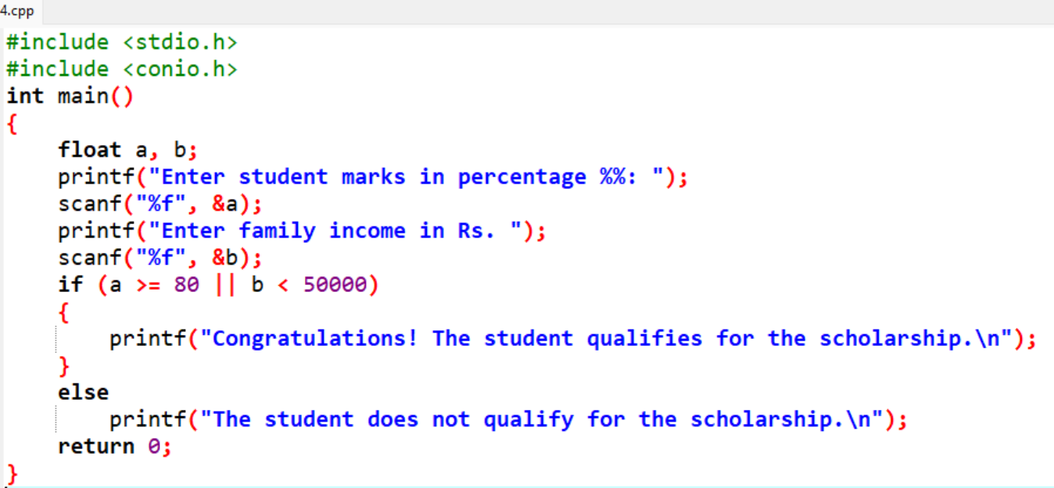

OUTPUT

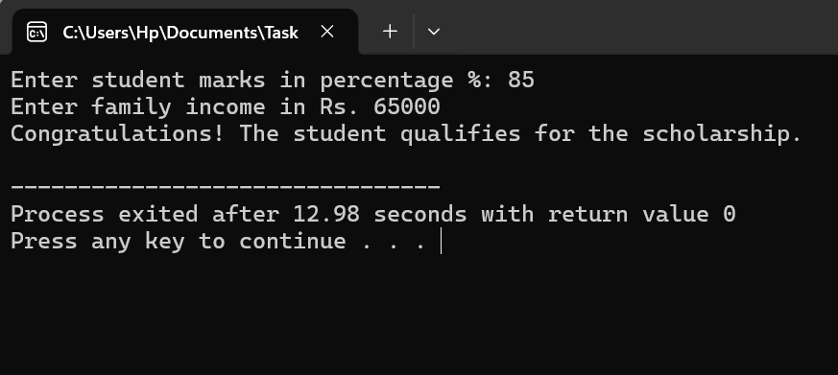

Task 2

A library wants to calculate a student's fine based on the number of late days. Ask the user to enter the number of late days using scanf(). If the student has 0 days, display "No Fine". If the late days are 1–5, display "Fine: Rs. 50". If the late days are 6–10, display "Fine: Rs. 100". For more than 10 days, display "Fine: Rs. 200". Use relational operators and nested if-else conditions.
CODE
#include <stdio.h>
#include <conio.h>
int main()
{
int lateDays;
printf("Enter the number of late days: ");
scanf("%d", &lateDays);
if (lateDays == 0)
{
printf("No Fine\n");
}
else
{
if (lateDays >= 1 && lateDays <= 5)
printf("Fine: Rs. 50\n");
else
{
if (lateDays >= 6 && lateDays <= 10)
printf("Fine: Rs. 100\n");
else
printf("Fine: Rs. 200\n");
}
}
return 0;
}
CODE SCREENSHOT

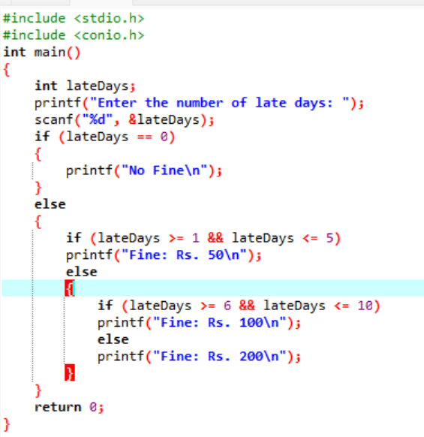
OUTPUT

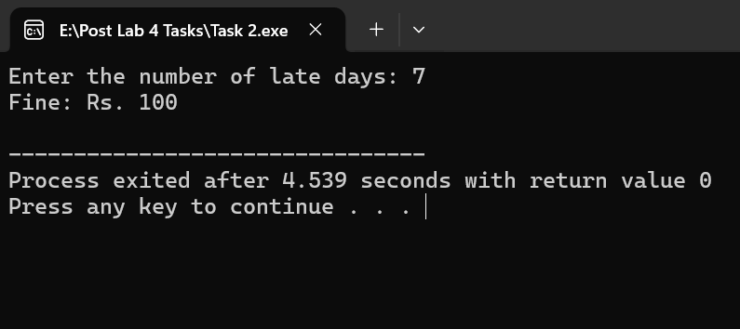

Task 3

A student registration system needs to collect a student's name. Write a C program that uses fgets() to take the student's full name, including spaces. Then use puts() to display a message containing the entered name. The program should demonstrate the difference between taking a complete line of text and a single character.
CODE
#include <stdio.h>
#include <conio.h>
int main()
{
char fullName[100];
char singleChar;
char name[100];
printf("Enter your full name (including spaces): ");
fgets(fullName, sizeof(fullName), stdin);
printf("You entered the full name using puts(): ");
puts(fullName);
printf("Enter your name again: ");
scanf("%s", name);
while (getchar() != '\n');
printf("Your name till first whitespace is: %s \n", name);
printf("\nEnter your name again: ");
scanf(" %c", &singleChar);
printf("Your first letter of name is: %c\n", singleChar);
printf("\nDifference Explanation:\n");
printf("- fgets() reads an entire line of text including spaces until a newline ('\\n') is encountered.\n");
printf("- Standard inputs like scanf() with %%s terminates at the first whitespace, and %%c captures a single character.\n");
return 0;
}

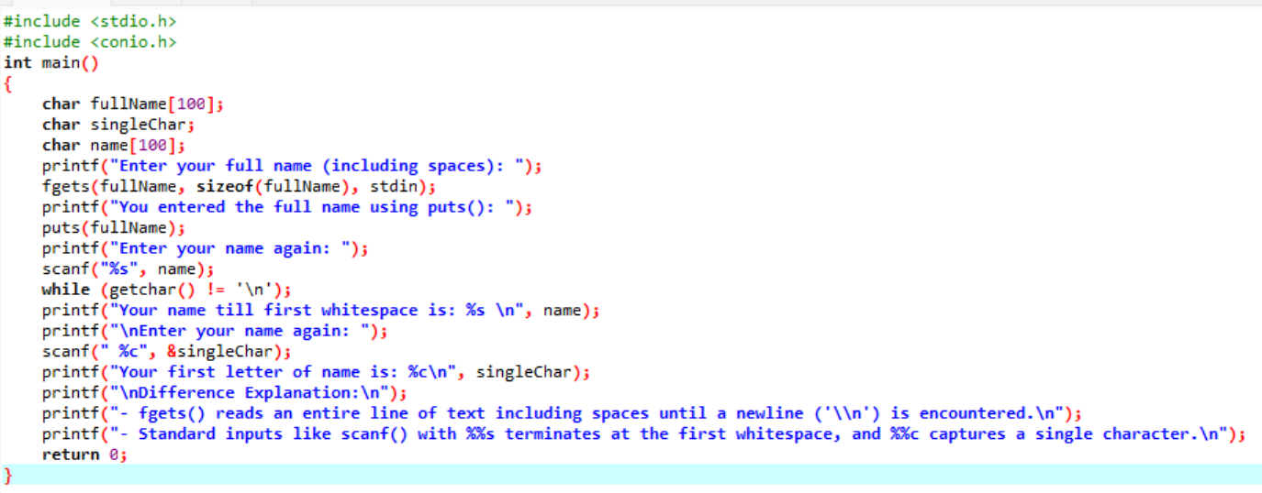
CODE SCREENSHOT

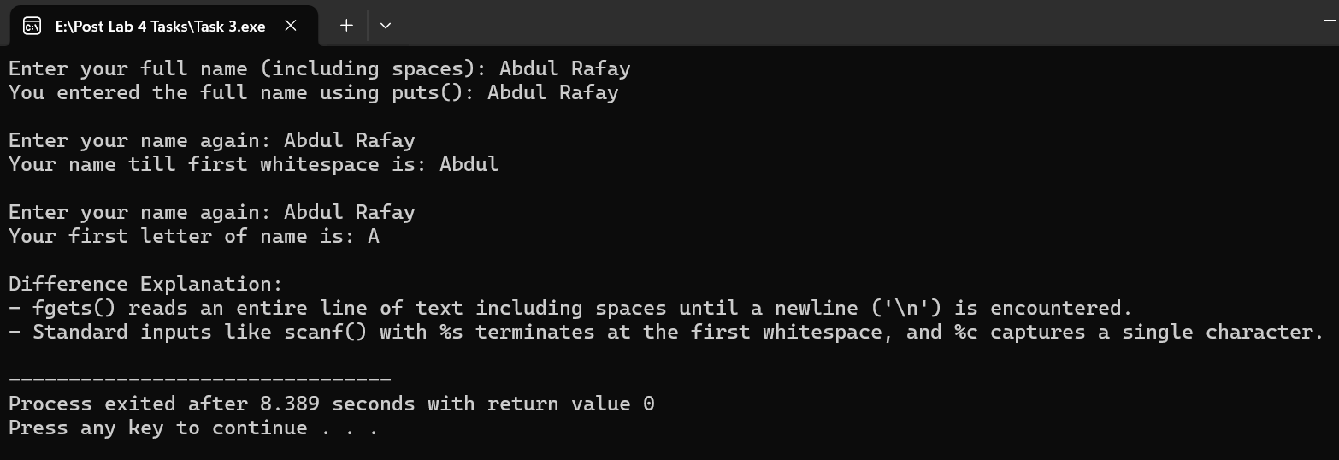
OUTPUT

Task 4

Write a C program that takes the length and width of a rectangle from the user and calculates its area and perimeter.
#include <stdio.h>
#include <conio.h>
int main()
{
float length, width, area, perimeter;
printf("Enter the length of the rectangle: ");
scanf("%f", &length);
printf("Enter the width of the rectangle: ");
scanf("%f", &width);
area=length*width;
perimeter=2*(length+width);
printf("Area of the rectangle: %f\n", area);
printf("Perimeter of the rectangle: %f\n", perimeter);
return 0;
}
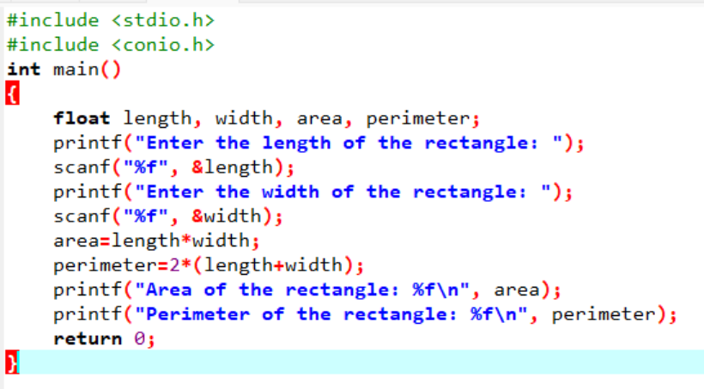
CODE
CODE SCREENSHOT

OUTPUT
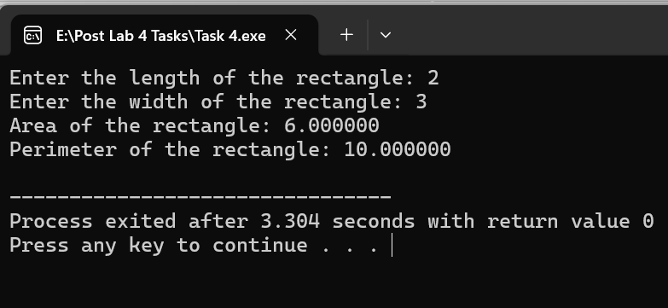

Task 5

Write a C program that takes an integer from the user and calculates and displays its square and cube.
#include <stdio.h>
#include <conio.h>
int main()
{
int num;
printf("Enter an integer: ");
scanf("%d", &num);
int square=num*num;
int cube=num*num*num;
printf("Square of %d is: %d\n", num, square);
printf("Cube of %d is: %d\n", num, cube);
return 0;
}
CODE
CODE SCREENSHOT
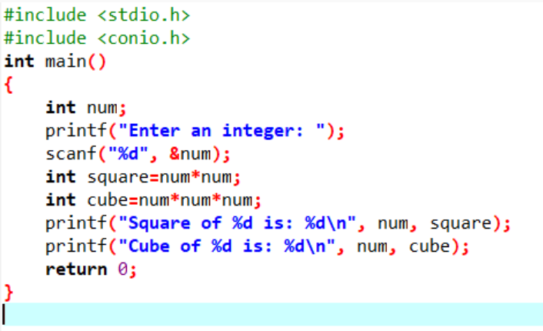
OUTPUT

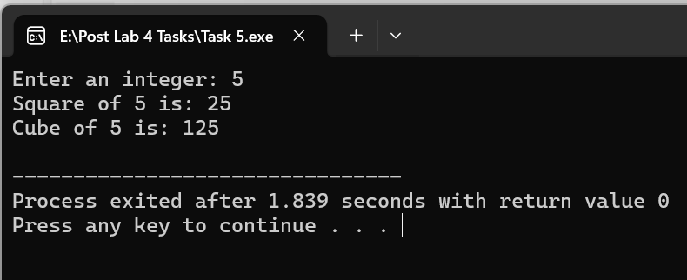

Task 6

Write a C program that takes temperature in Celsius from the user and converts it into Fahrenheit using the formula: F = (C × 9/5) + 32.
#include <stdio.h>
#include <conio.h>
int main()
{
float celsius, fahrenheit;
printf("Enter temperature in Celsius: ");
scanf("%f", &celsius);
fahrenheit = (celsius*9.0/5.0)+32.0;
printf("Temperature in Fahrenheit: %f F\n", fahrenheit);
return 0;
}
CODE
CODE SCREENSHOT
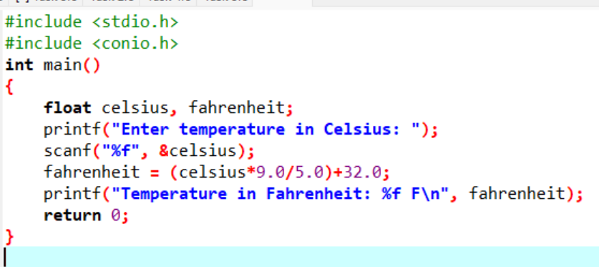

OUTPUT

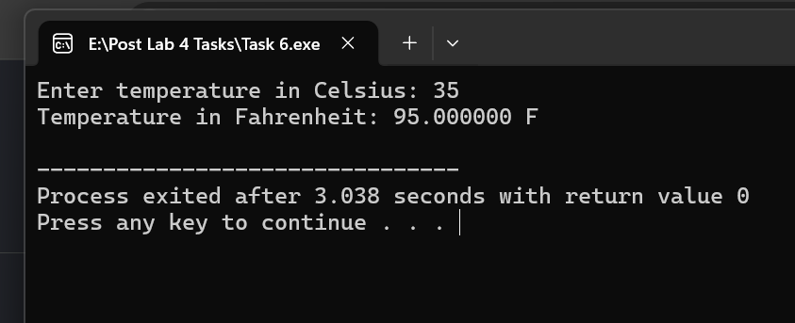

Task 7

Write a C program that takes three numbers from the user and calculates and displays their average.
#include <stdio.h>
#include <conio.h>
int main()
{
float num1, num2, num3, average;
printf("Enter three numbers separated by spaces: ");
scanf("%f %f %f", &num1, &num2, &num3);
average = (num1 + num2 + num3) / 3.0;
printf("The average is: %f\n", average);
return 0;
}
CODE
CODE SCREENSHOT
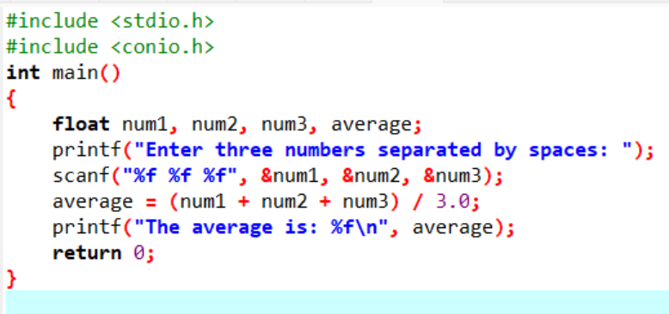

OUTPUT

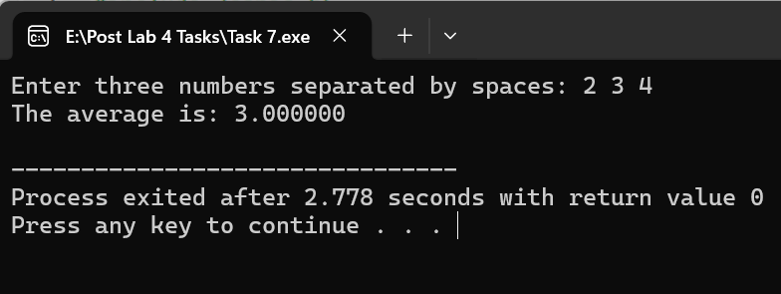

Task 8

Write a C program that takes a student's marks and displays "Pass" if the marks are 50 or above otherwise , display " Fail".
#include <stdio.h>
#include <conio.h>
int main()
{
float marks;
printf("Enter student marks: ");
scanf("%f", &marks);
if (marks >= 50.0)
printf("Pass\n");
else
printf("Fail\n");
return 0;
}
CODE
CODE SCREENSHOT
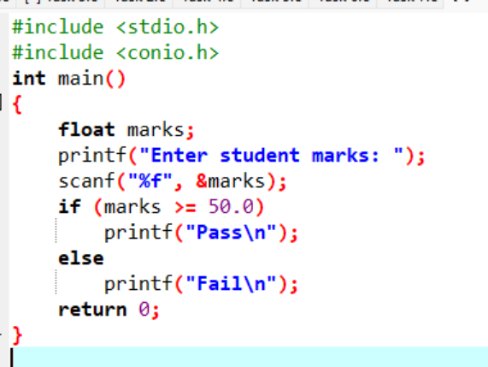

OUTPUT

